Task - 1

Air Ticket Information

AIM : Create html web page for Air ticket reservation

• Make use of marquee tag( to scroll vertically up), image tag, table and

link tag for designing your web page.

• Mention the flight number, name , departure and arrival details of all

flights inside a table. (minimum 10 trains)

• When user clicks on particular train, he/she should be able to see list of

all stops with timings details.

• You can also make use of Text formatting tags.

• Add a food delivery webpage in aeroplane info and connect to Air

ticket information system.

HTML TAGS USED IN THIS WEB PAGE :

* <head> - Heading content of the html file
* <body> - Body content of the html file
* <link> - To link CSS file
* <nav> - Navigation tag to place nav bar options
* <div> - To create a division like a separate container
* <img> - To link an image into the website
* <hx> - heading tag followed by a number noting its size
* <p> - Paragraph tag for text
* <ul> - Un-ordered list
* <a> - Attribute link tag
* <marquee> - marquee tag is used to make scrolling test
* <table> - To Create tables in html
* <tr> - Table Row
* <td> - Table Data of the row
* <th> - Heading of table row
* <strong> - To Make strong-bold text
* <details> - To create a button like thing to show description
* <summary> - To Display a summary for details tag

HTML CODE FOR MAIN WEB PAGE :

<!DOCTYPE html>

<html lang="en">

<head>

<meta charset="UTF-8">

<meta http-equiv="X-UA-Compatible" content="IE=edge">

<meta name="viewport" content="width=device-width, initial-scale=1.0">

<title>AIRLINES Information</title>

<link rel="stylesheet" href="styles.css">

</head>

<body>

<nav class="navbar">

<div class="container">

<img src="logo.png" style="width: 80%;">

<h1 class="logo">QT</h1>

<ul class="nav">

<li><a href="#home">Home</a></li>

<li><a href="food.html">Order Food</a></li>

<li><a href="#About">About</a></li>

</ul>

<ul class="nav">

<li><a href="#home">Log-in</a></li>

</ul>

</div>

</nav> <br><br>

<marquee behavior="" direction=""><h1>----Available flights----</h1></marquee>

<table>

<tr>

<th><strong>FLIGHT NAME</strong></th>

<th><strong>FLIGHT NUMBER</strong></th>

<th><strong>STARTS FROM</strong></th>

<th><strong>DESTINATION</strong></th>

<th><strong>DEPARTURE</strong></th>

<th><strong>ARRIVAL</strong></th>

</tr>

<tr>

<td><details><summary> SPICEJET</summary>

<p>Flight stops</p>

<table style="width:50%">

<tr>

<th>AIRPORT</th>

<th>LAY OVER</th>

</tr>

<tr>

<td>HYDERABAD</td>

<td>5m</td>

</tr>

<tr>

</table></details> </td>

<td>21120</td>

<td>VISAKHAPATNAM</td>

<td>CHENNAI</td>

<td>06:00 AM</td>

<td>15:30 PM</td>

</tr>

<tr>

<td><details><summary>Indigo</summary>

<p>Flight stops</p>

<table style="width:50%">

<tr>

<th>AIRPORT</th>

<th>LAY OVER</th>

</tr>

<tr>

<td>VISAKHAPATNAM</td>

<td>10m</td>

</tr>

<tr>

<td>KOLKATA</td>

<td>25m</td>

</tr>

</table></details></td>

<td>21121</td>

<td>BANGALORE</td>

<td>VISHAKAPATNAM</td>

<td>06:30 AM</td>

<td>12:15 PM</td>

</tr>

<tr>

<td><details><summary>Ethiad</summary>

<p>Flight stops</p>

<table style="width:50%">

<tr>

<th>AIRPORT</th>

<th>LAY OVER</th>

</tr>

<tr>

<td>KOLKATA</td>

<td>30m</td>

</tr>

<tr>

<td>JAIPUR</td>

<td>15m</td>

</tr>

</table></details> </td>

<td>21122</td>

<td>VISAKHAPATNAM</td>

<td>USA</td>

<td>08:25 AM</td>

<td>24:10 PM</td>

</tr>

<tr>

<td><details><summary>Lufthansa</summary>

<p>Flight stops</p>

<table style="width:50%">

<tr>

<th>AIRPORT</th>

<th>LAY OVER</th>

</tr>

<tr>

<td>BHUBANESWAR</td>

<td>40m</td>

</tr>

<tr>

<td>JAIPUR</td>

<td>25m</td>

</tr>

<tr>

<td>KASHMIR</td>

<td>18m</td>

</tr>

</table>

</details> </td>

<td>21123</td>

<td>BANGLORE</td>

<td>QATAR</td>

<td>09:05 AM</td>

<td>23:30 PM</td>

</tr>

<tr>

<td><details><summary>Air india</summary>

<p>Flight stops</p>

<table style="width:50%">

<tr>

<th>AIRPORT</th>

<th>LAY OVER</th>

</tr>

<tr>

<td>BHUBANESWAR</td>

<td>40m</td>

</tr>

<tr>

<td>JAIPUR</td>

<td>25m</td>

</tr>

<tr>

<td>KASHMIR</td>

<td>18m</td>

</tr>

</table></details> </td>

<td>21124</td>

<td>HYDERABAD</td>

<td>JAIPUR</td>

<td>15:00 PM</td>

<td>18:00 PM</td>

</tr>

<tr>

<td><details><summary>Jet airways</summary>

<p>Flight stops</p>

<table style="width:50%">

<tr>

<th>AIRPORT</th>

<th>LAY OVER</th>

</tr>

<tr>

<td>BHUBANESWAR</td>

<td>40m</td>

</tr>

<tr>

<td>JAIPUR</td>

<td>25m</td>

</tr>

<tr>

<td>KASHMIR</td>

<td>18m</td>

</tr>

</table></details> </td>

<td>21125</td>

<td>Delhi</td>

<td>VISAKHAPATNAM</td>

<td>14:00 PM</td>

<td>18:30 PM</td>

</tr>

<tr>

<td><details><summary>AKASA AIR</summary>

<p>Flight stops</p>

<table style="width:50%">

<tr>

<th>AIRPORT</th>

<th>LAY OVER</th>

</tr>

<tr>

<td>BANGALORE</td>

<td>5m</td>

</tr>

<tr>

</table></details> </td>

<td>21126</td>

<td>VISAKHAPATNAM</td>

<td>BOMBAY</td>

<td>18:00 PM</td>

<td>00:45 PM</td>

</tr>

<tr>

<td><details><summary> DELTA AIRLINES</summary>

<p>Flight stops</p>

<table style="width:50%">

<tr>

<th>AIRPORT</th>

<th>LAY OVER</th>

</tr>

<tr>

<td>JAIPUR</td>

<td>45m</td>

</tr>

<tr>

<td>SAN FRANSISCO</td>

<td>25m</td>

</tr>

<tr>

<td>KASHMIR</td>

<td>18m</td>

</tr>

</table></details> </td>

<td>21127</td>

<td>BOMBAY</td>

<td>NEW YORK</td>

<td>11:00 AM</td>

<td>23:00 PM</td>

</tr>

<tr>

<td><details><summary>FLY HIGH</summary>

<p>Flight stops</p>

<table style="width:50%">

<tr>

<th>AIRPORT</th>

<th>LAY OVER</th>

</tr>

<tr>

<td>VISAKHAPATNAM</td>

<td>10m</td>

</tr>

<tr>

<td>CHENNAI</td>

<td>5m</td>

</tr>

</table></details></td>

<td>21128</td>

<td>AMRITSAR</td>

<td>KERALA</td>

<td>19:00 PM</td>

<td>23:45 PM</td>

</tr>

<tr>

<td><details><summary>FRONTIER</summary>

<p>Flight stops</p>

<table style="width:50%">

<tr>

<th>AIRPORT</th>

<th>LAY OVER</th>

</tr>

<tr>

<td>VISAKHAPTNAM</td>

<td>10m</td>

</tr>

<tr>

<td>BOMBAY</td>

<td>25m</td>

</tr>

</table></details></td>

<td>21129</td>

<td>COCHIN</td>

<td>JAIPUR</td>

<td>15:10 PM</td>

<td>23:45 PM</td>

</tr>

</table>

</body>

</html>

CSS CODE FOR Main Site :

body{

background-image: url('indexbg.jpg');

background-color: rgba(0,0,0,0.8);

}

table {

border-collapse: collapse;

width: 100%;

background-color: rgba(0,0,0,0.6);

}

td , th{

border: 1px solid black;

border-collapse: collapse;

text-align: left;

padding: 8px;

}

.navbar a{

color: black;

text-decoration: none;

}

.navbar a:hover{

text-decoration: underline;

cursor: pointer;

text-decoration-color: #fff;

font-size: 104%;

position: static;

}

ul{

list-style: none;

}

.container{

width: 1100px;

margin: auto;

overflow: hidden;

padding: 0 1rem 0;

}

.navbar{

font-size: 1.5rem;

/* padding-top: 0.6rem;

padding-bottom: 1rem; */

background-color: rgba(0,0,0,0.16);

border-bottom-left-radius: 4rem;

border-bottom-right-radius: 4rem;

/* border: 2rem; */

height: 80px;

align-self: center;

justify-content: flex-start;

}

.navbar .container{

display: grid;

grid-template-columns: 0.1fr 0.4fr 1fr 0.3fr;

}

.navbar .container img{

padding-top: 1.8rem;

}

.navbar .nav{

justify-self: flex-start;

display: flex;

justify-content: flex-start;

/* border-radius: 4rem; */

}

.navbar .nav a{

padding: 0 1rem 0;

}

.navbar .nav:hover{

color: antiquewhite;

}

*{

color: #fff;

}

SCREENSHOTS :

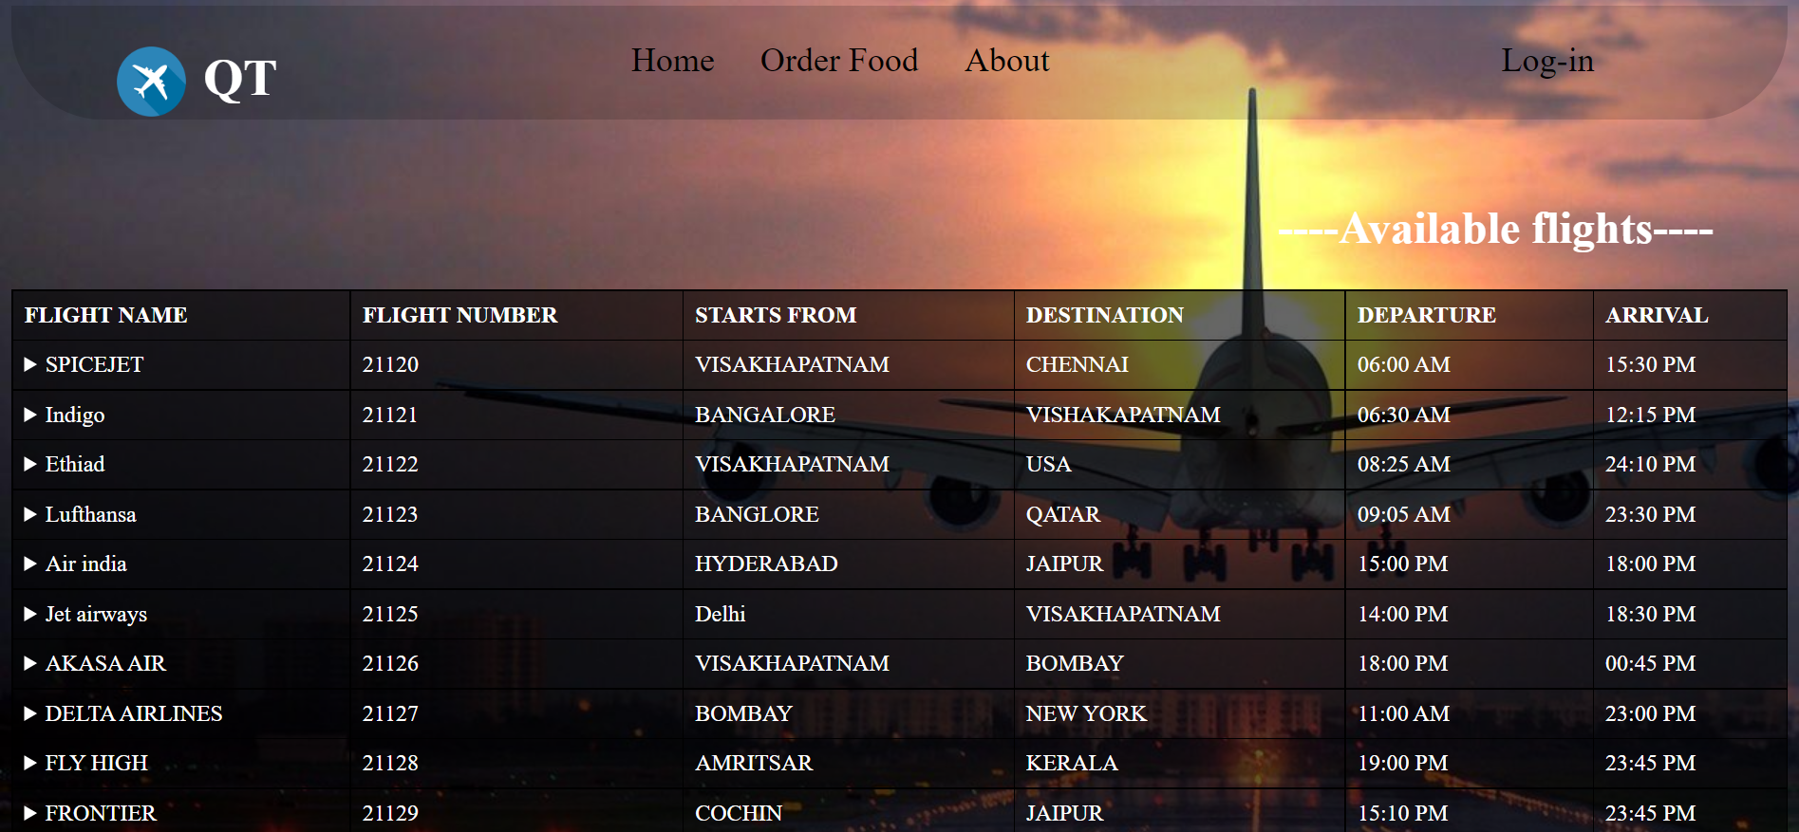

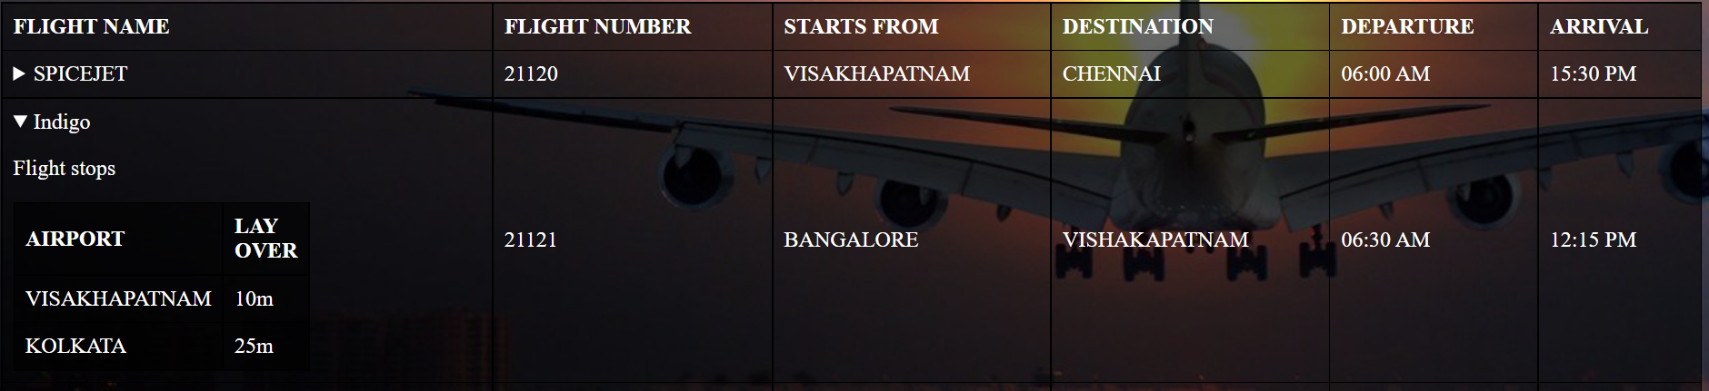

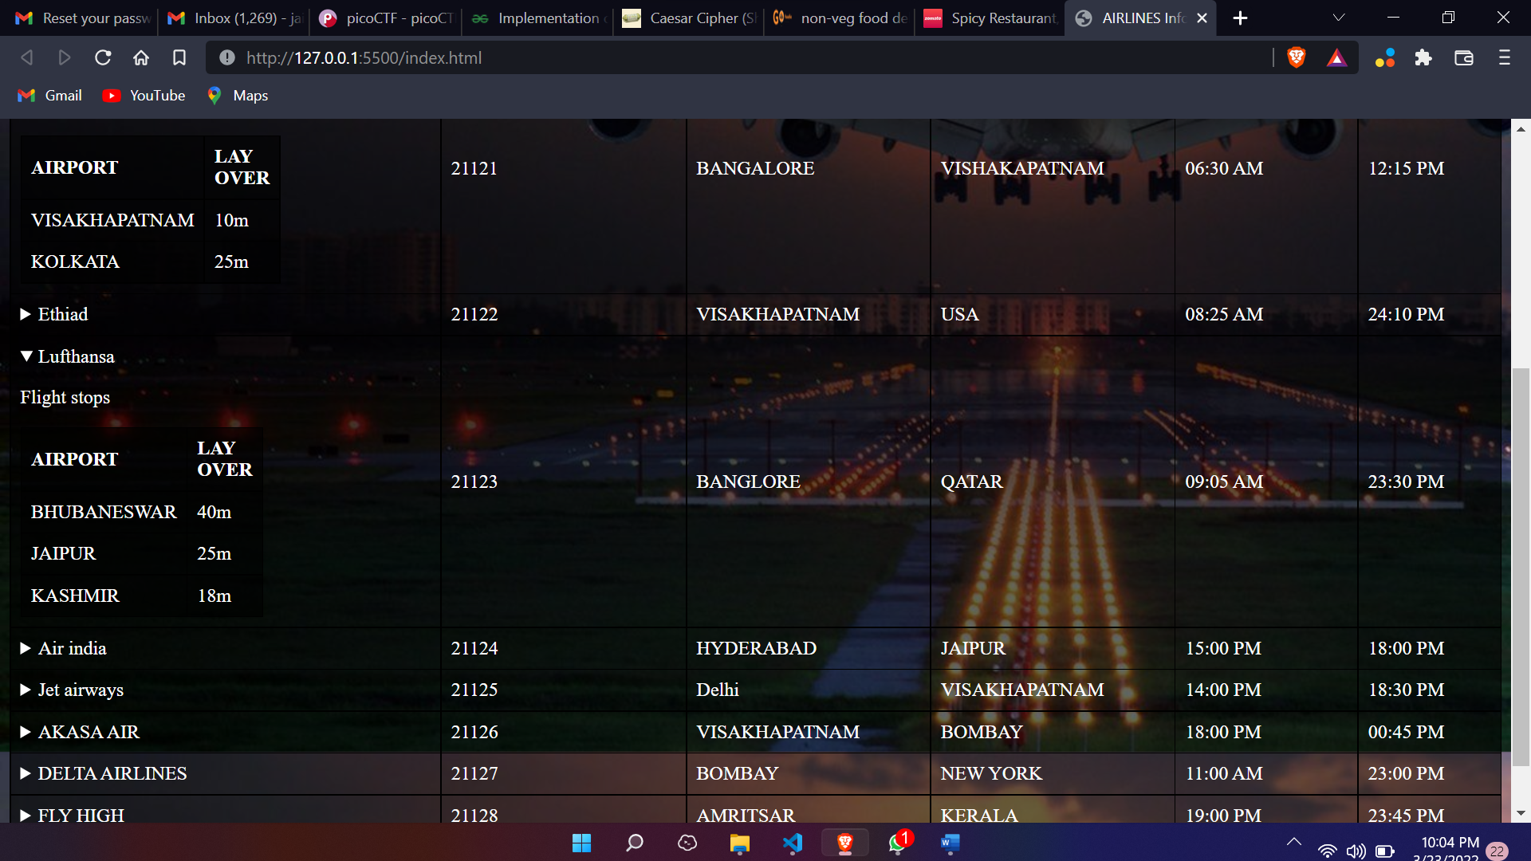

FOOD ORDERING PAGE SOURCE:

<!DOCTYPE html>

<html lang="en">

<head>

<meta charset="UTF-8">

<meta http-equiv="X-UA-Compatible" content="IE=edge">

<meta name="viewport" content="width=device-width, initial-scale=1.0">

<title>Order Your Food</title>

<link rel="stylesheet" href="food.css">

</head>

<body>

<nav class="nav">

<div class="logo">

<img class="logoimage" src="foodlogo.png" alt="logo">

<p class="logotitle">Food in Air</p>

</div>

<div class="nav-options">

<p>Home</p>

<p>About us</p>

<p>Contact us</p>

</div>

</nav>

<div class="MainDescription">

<h1>Food on Air</h1>

<p>

is a trusted online food booking website to order food on

</p>

<h2>We are recognized and certified by Air Amrita</h2>

<p>

This is a most trusted online food delivery in AirWays that allows International flight passengers to online food order in their seats , of their choice from the wide variety of food menu for particular Class while travelling in Air. We have Air food service of meals , Breakfast, lunch, evening snacks, drinks and dinner. Book food & get delivery of desired food in ur seat ie, Jain food, pure veg, non veg food delivery in Air. We believe to serve fresh, quality, hygienic food deliver in a very convenient packaging from best restaurants or hotels, fssai certified at over 280+ Airports internationally for passenger's from our delivery food partners like Air india , spice jet , ethiad , hukyard , etc.

</p>

</div>

<marquee behavior="" direction=""><h1>----Food menu----</h1></marquee>

<div class="Categories">

<a href="#Recommended">Recommended</a>

<a href="#Combos">Combos</a>

<a href="#Signature">Signature dishes</a>

<a href="#Soups">soups</a>

<a href="#Starters">Starters</a>

<a href="#Veg">Veg Main</a>

<a href="#Non-veg">Non veg</a>

<a href="#Drinks">Drinks</a>

</div>

<div class="menu">

<div class="Recommended" id="Recommended">

<div class="ToDos" id="ToDos">

<img src="res/grilled.jpg" alt="">

<span id="title" class="title">

Grilled chicken

</span>

<span id="de" class="de"> £299</span>

<span id="dat" class="dat">Add to cart</span>

</div>

<div class="ToDos" id="ToDos">

<span id="title" class="title">

Item name

</span>

<span id="de" class="de"> <span>Description:</span>

price

</span> <br> <br>

<span id="dat" class="dat"> <span> Deadline: </span>

Add to cart

</span>

</div>

</div>

</div>

<div class="Combos" id="Combos">

<div class="ToDos" id="ToDos">

<img src="res/grilled.jpg" alt="">

<span id="title" class="title">

Grilled chicken

</span>

<span id="de" class="de"> <span>Description:</span>

price

</span> <br> <br>

<span id="dat" class="dat"> <span> Deadline: </span>

Add to cart

</span>

</div>

<div class="ToDos" id="ToDos">

<span id="title" class="title">

Item name

</span>

<span id="de" class="de"> <span>Description:</span>

price

</span> <br> <br>

<span id="dat" class="dat"> <span> Deadline: </span>

Add to cart

</span>

</div>

</div>

</div>

<div class="delivery">

<p>Enter the details to get the delivery</p>

<input type="text" name="" placeholder="Flight number" id="">

<button>submit</button>

</div>

</body>

</html>

SCREENSHOTS :

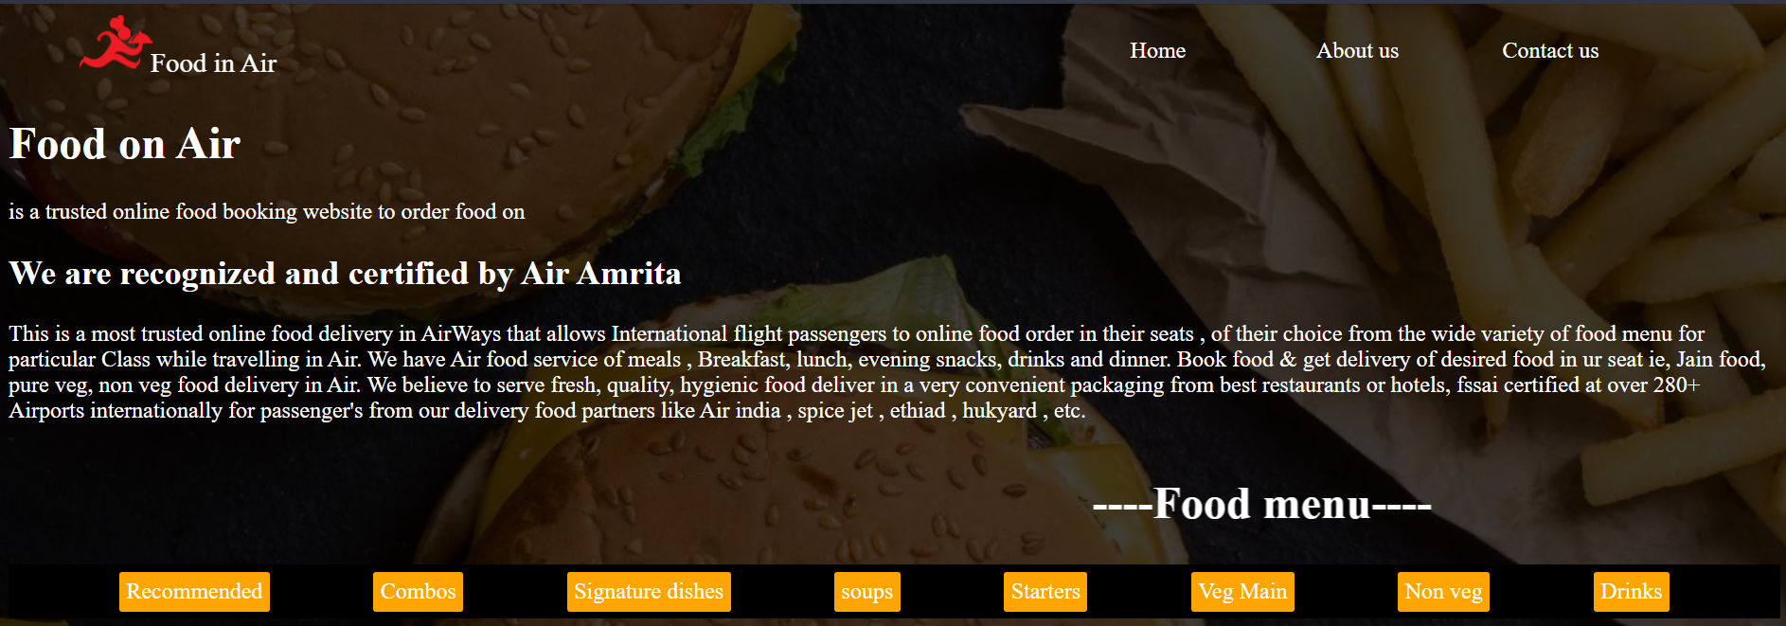

CONCLUSION :

1) We have successfully created a webpage on airticket

system information.

2) By using various html tags which redirected to create

this webpage.

3) Also created a food delivery option for the

passengers those who want to eat the food in our airways.

Task - 2

Tourist guide map

AIM : Create html web page for tourists to know about places

* Design a tourist information webpage implementing image hotspot to get useful information about the countries.
* Your webpage should allow the user to select the favourite country from the list box. After selecting, new page should be opened in another tab displaying the country map.
* Implement image hot spot for the country map showing tourist place details for atleast 3 states.
* Make sure all links are opened in new tab.
* You can use additional html tags to make your web page more attractive

HTML TAGS USED IN THIS WEB PAGE :

* <html> - Starting to any html document
* <head> - Heading content of the html file
* <title> - To specify the heading of the page
* <body> - Body content of the html file
* <link> - To link CSS file
* <div> - To create a division like a separate container
* <img> - To link an image into the website
* <select> - To provide user a choice from drop-down
* <option> - To display the available options
* <hx> - heading tag followed by a number noting its size
* <p> - Paragraph tag for text
* <map> - To create hotspot locations on map
* <area> - To specify hotspot area’s

HTML CODE FOR MAIN WEB PAGE :

<!DOCTYPE html>

<html lang="en">

<head>

<meta charset="UTF-8">

<meta http-equiv="X-UA-Compatible" content="IE=edge">

<meta name="viewport" content="width=device-width, initial-scale=1.0">

<title>Tourist Guide</title>

<link rel="stylesheet" href="res/styles.css">

</head>

<body>

<div>

<P>Choose any country:</P>

<select onchange="window.open(this.options[this.selectedIndex].value,'_blank');">

<option></option>

<option value="ind/india.html">India</option>

<option value="mada/madagascar.html">Madagascar</option>

<option value="ny/newyork.html">New York</option>

</select>

</div>

<div id="popup-overlay"></div>

</body>

</html>

CSS CODE FOR Main Site :

body{

background-image: url("b.jpg");

background-repeat: no-repeat;

background-size: 100% ;

}

body div{

position: fixed;

transform: translate(-50%, -50%);

transition: 200ms ease-in-out;

border: none;

border-radius: 20px;

background-color: rgba(255,255,255,1);

box-shadow: 0 15px 30px rgba(0,0,0,.4);

max-width: 80%;

color: black;

align-items: center;

left: 50%;

top: 50%;

width: 400px;

align-items:stretch;

z-index: 97;

}

body div p{

padding-left: 20px;

font-size: 120%;

color: rgba(0,0,0,2);

z-index: 98;

}

body div select{

background-color: rgba(255,255,255,.2);

border: none;

/* border-bottom: 1px solid black; */

outline: none;

cursor: pointer;

z-index: 100;

width: 100%;

padding-left: 9px;

border-bottom-left-radius: 20px;

border-bottom-right-radius: 20px ;

z-index: 99;

}

#popup-overlay{

position: fixed;

top: 0;

left: 0;

right: 0;

bottom: 0;

height: 200%;

padding-left: 9000px;

background: rgba(0,0,0,.4);

pointer-events: none;

}

SCREENSHOTS :



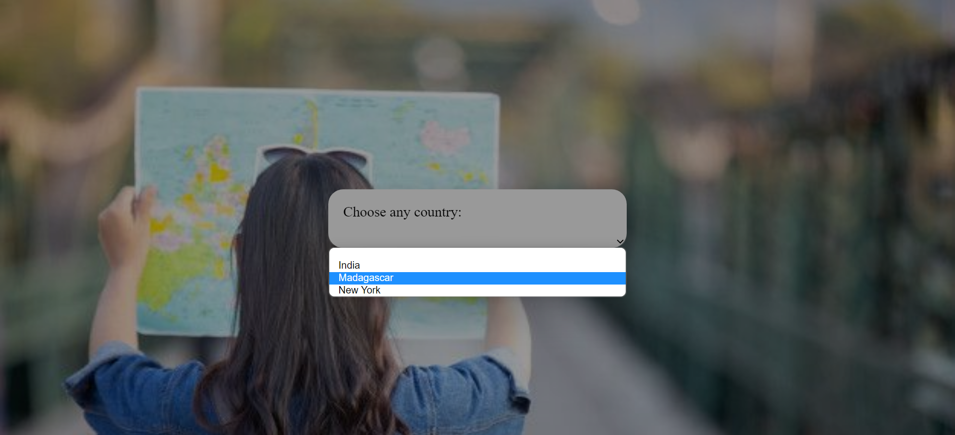

Country PAGE SOURCE:

India:

<!DOCTYPE html>

<html lang="en">

<head>

<meta charset="UTF-8">

<meta http-equiv="X-UA-Compatible" content="IE=edge">

<meta name="viewport" content="width=device-width, initial-scale=1.0">

<title>India</title>

<style>

body{

background-size:cover;

background: linear-gradient(-45deg, #d9a7c7, #eca9d4, #e7e2b4, #fffcdc);

background-size: 400% 400%;

animation: gradient 9s ease infinite;

height: 100vh;

}

@keyframes gradient {

0% {

background-position: 0% 50%;

}

50% {

background-position: 100% 50%;

}

100% {

background-position: 0% 50%;

}

}

</style>

</head>

<body>

<img src = ind.gif alt = "usemap" usemap = "#lessons"/>

<map name = "lessons">

<!-- kerala -->

<area shape="poly" coords="231,915 , 283,954 , 317,1030 , 300,1067 , 248,947" href="kerala.html" alt="" target="_blank">

<!-- Tamil nadu -->

<area shape="poly" coords="416,892 , 403,999 , 316,1077 , 314,952 , 338,922 " href="tn.html" alt="" target="_blank">

<!-- Andhra -->

<area shape="poly" coords="563,682 , 446,794 , 378,897 , 303,836 , 326,809" href="ap.html" alt="">

<!-- karnataka -->

<area shape="poly" coords="324,719 , 296,851 , 350,897 , 288,951 , 209,837 , 227,779 " href="karnataka.html" alt="" target="_blank">

<!-- teangana -->

<area shape="poly" coords="324,719 , 296,851 , 350,897 , 288,951 , 209,837 , 227,779 " href="ts.html" alt="" target="_blank">

</map>

</body>

</html>

Madagascar:

<!DOCTYPE html>

<html lang="en">

<head>

<meta charset="UTF-8">

<meta http-equiv="X-UA-Compatible" content="IE=edge">

<meta name="viewport" content="width=device-width, initial-scale=1.0">

<title>Madagascar</title>

<style>

body{

background-size:cover;

background: linear-gradient(-45deg, #d9a7c7, #eca9d4, #e7e2b4, #fffcdc);

background-size: 400% 400%;

animation: gradient 9s ease infinite;

height: 100vh;

}

@keyframes gradient {

0% {

background-position: 0% 50%;

}

50% {

background-position: 100% 50%;

}

100% {

background-position: 0% 50%;

}

}

</style>

</head>

<body>

<img src = mada.gif alt = "usemap" usemap = "#lessons"/>

<map name = "lessons">

<!-- Fiana -->

<area shape="poly" coords="591,742 , 390,1046 , 326,984 , 238,947 , 300,695" href="Fiana.html" alt="" target="_blank">

<!-- antana -->

<area shape="poly" coords="470,529 , 452,702 , 360,719 , 300,619 , 280,599 , 314,526 " href="ant.html" alt="" target="_blank">

<!-- antsir -->

<area shape="poly" coords="574,36 , 673,311 , 649,366 , 634,308 , 561,219 , 465,183 , 537,152 , 544,76" href="ants.html" alt="" target="_blank">

</map>

</body>

</html>

Newyork:

<!DOCTYPE html>

<html lang="en">

<head>

<meta charset="UTF-8">

<meta http-equiv="X-UA-Compatible" content="IE=edge">

<meta name="viewport" content="width=device-width, initial-scale=1.0">

<title>New York</title>

<style>

body{

background-size:cover;

background: linear-gradient(-45deg, #d9a7c7, #eca9d4, #e7e2b4, #fffcdc);

background-size: 400% 400%;

animation: gradient 9s ease infinite;

height: 100vh;

}

@keyframes gradient {

0% {

background-position: 0% 50%;

}

50% {

background-position: 100% 50%;

}

100% {

background-position: 0% 50%;

}

}

</style>

</head>

<body>

<img src = nyc.gif alt = "usemap" usemap = "#lessons"/>

<map name = "lessons">

<!-- kerala -->

<area shape="poly" coords="812,50 , 809,70 , 812,104 , 746,119 , 733,52" href="clinton.html" alt="" target="_blank">

<!-- Tamil nadu -->

<area shape="poly" coords="729,51 , 714,119 , 718,123 , 721,156 , 669,159 , 655,52 " href="franklin.html" alt="" target="_blank">

<!-- teangana -->

<area shape="poly" coords="634,50 , 654,57 , 668,160 , 601,167 , 510,116 " href="st.html" alt="" target="_blank">

</map>

</body>

</html>

SCREENSHOTS :

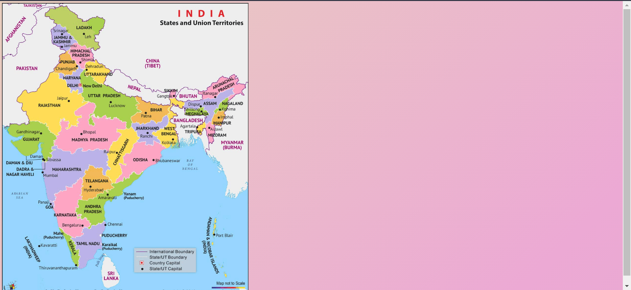

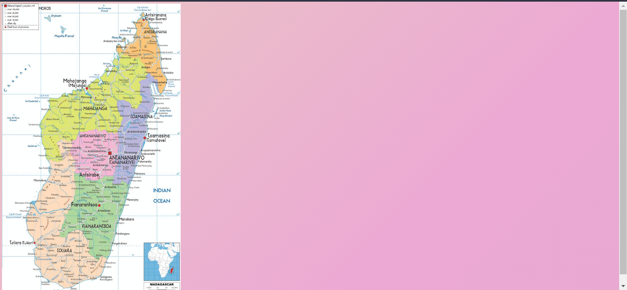

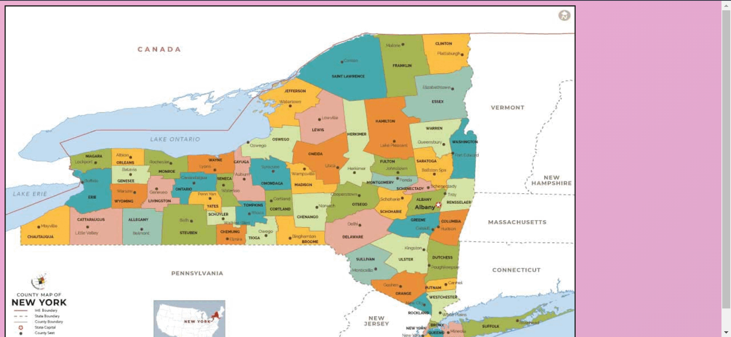

State PAGE SOURCE sample :

Andhra Pradesh:

<!DOCTYPE html>

<html lang="en">

<head>

<meta charset="UTF-8">

<meta http-equiv="X-UA-Compatible" content="IE=edge">

<meta name="viewport" content="width=device-width, initial-scale=1.0">

<title>Andhra pradesh</title>

<link rel="stylesheet" href="../res/states.css">

</head>

<body>

<img src="ap.jpg" alt="" srcset="">

<div class="main">

<h1>Andhra Pradesh</h1>

<hr>

<h2>Tourist spots</h2>

<!-- Portfolio Gallery Grid -->

<div class="row">

<div class="column">

<div class="content">

<h3>KHAJURAHO</h3>

<p>Lorem, ipsum dolor sit amet consectetur adipisicing elit. Nulla accusantium culpa voluptatum non aliquid quidem excepturi modi. Consequuntur sit atque ipsum odit cum, eaque doloremque deserunt commodi at neque quas.</p>

</div>

</div>

<div class="column">

<div class="content">

<h3>PACHAMARHI</h3>

<p>Lorem, ipsum dolor sit amet consectetur adipisicing elit. Impedit reprehenderit voluptas fugit facilis consectetur deleniti, in beatae quis numquam quidem molestias consequuntur quod! Magnam error libero voluptatem corporis. Provident, qui.</p>

</div>

</div>

<div class="column">

<div class="content">

<h3>KANHA-NATIONAL-PARK</h3>

<p>Lorem ipsum dolor, sit amet consectetur adipisicing elit. Temporibus, molestias aperiam. Sunt sint, qui vel dolor recusandae modi ut necessitatibus a, tenetur, nemo ratione dolore fugit optio facilis ea beatae.</p>

</div>

</div>

<div class="column">

<div class="content">

<h3>SANCHI</h3>

<p>Lorem ipsum dolor, sit amet consectetur adipisicing elit. Minus voluptatem, cupiditate vel nobis voluptatum eveniet odit qui perferendis pariatur quisquam maiores odio. Accusamus minus et natus a nisi, repudiandae qui!</p>

</div>

</div>

</div>

<div class="content">

<h3>UJJAIN</h3>

<p>Lorem ipsum dolor sit, amet consectetur adipisicing elit. Expedita quia cum, repellat debitis in modi quasi ullam perferendis sapiente, at vero, accusantium sit excepturi? Ipsa saepe, asperiores porro non dignissimos sequi, architecto doloremque quis, molestiae perferendis harum accusantium ullam fugit molestias deleniti iste ad eos repudiandae quo quia. Numquam, in.</p>

</div>

</div>

</body>

</html>

State PAGE CSS:

* {

box-sizing: border-box;

}

body {

background-color: #f1f1f1;

padding: 20px;

font-family: Arial;

}

.main {

max-width: 1000px;

margin: auto;

}

h1 {

font-size: 50px;

word-break: break-all;

}

.row {

margin: 8px -16px;

}

.row,

.row > .column {

padding: 8px;

}

.column {

float: left;

width: 25%;

}

.row:after {

content: "";

display: table;

clear: both;

}

.content {

background-color: white;

padding: 10px;

}

@media screen and (max-width: 900px) {

.column {

width: 50%;

}

}

@media screen and (max-width: 600px) {

.column {

width: 100%;

}

}

body {

background: linear-gradient(-45deg, #CAC531, #F3F9A7, #adbe0e80, #c9d523);

background-size: 400% 400%;

animation: gradient 9s ease infinite;

height: 100vh;

}

@keyframes gradient {

0% {

background-position: 0% 50%;

}

50% {

background-position: 100% 50%;

}

100% {

background-position: 0% 50%;

}

}

SCREENSHOTS :

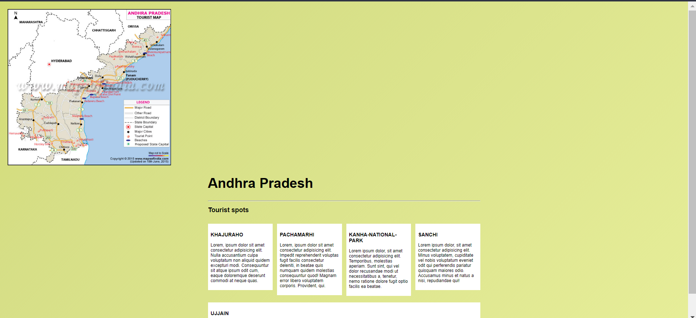

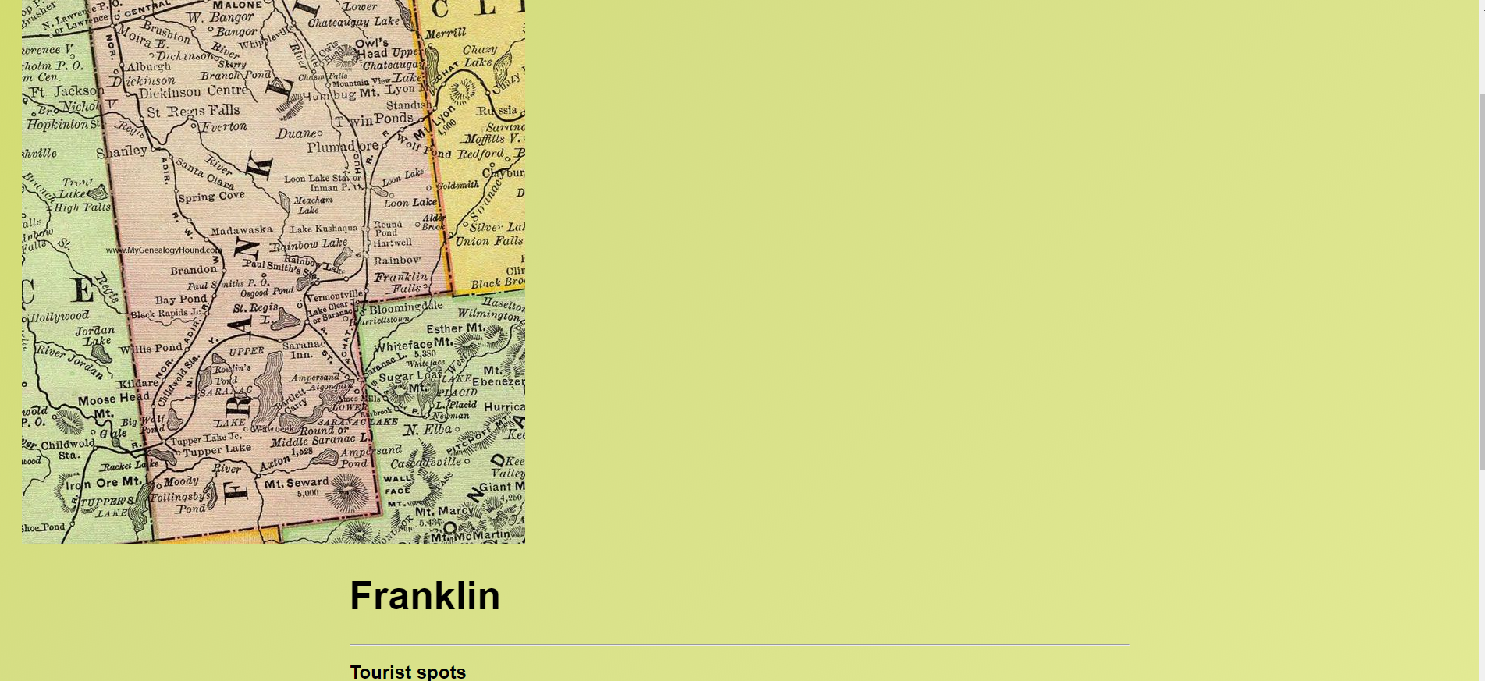

CONCLUSION :

1) We have successfully created a webpage for tourists to explore tourists spots

2) By using various html tags which redirected to create

this webpage.

3) Also created Separate country map pages along with separate state maps detailing the tourist spots available.

Task - 3

Science conference webpage

AIM : Create html web page for advertising about Science Symposium/Conference that is yet to happen in your department.

* Your web page should display at least best technical science project videos that was presented in last year.
* Make videos to scroll in your web page.
* Mention the Event name, Event date, Project submission deadlines, Abstract Submission and payment details of conference/event in detail. Use Bookmark link to move to different parts of same page.
* You can also add audio link if required in your web page.
* Use iframes and basic formatting tags and add more creativity to your web page.

HTML TAGS USED IN THIS WEB PAGE :

* <html> - Starting to any html document
* <head> - Heading content of the html file
* <title> - To specify the heading of the page
* <body> - Body content of the html file
* <link> - To link CSS file
* <div> - To create a division like a separate container
* <img> - To link an image into the website
* <a> - To link any webpage bookmarks
* <marquee> - To Scroll text in a webpage
* <centre> - To place content in the tag in centre padding
* <pre> - To display content on the web page as-it-is typed in document
* <br> - breaking line and print on next line
* <hx> - heading tag followed by a number noting its size
* <header> - To specify main headings
* <p> - Paragraph tag for text
* <audio> - To insert audio files into the webpage
* <source> - To specify the audio file location
* <iframe> - To Insert any youtube or video from internet

HTML CODE FOR MAIN WEB PAGE :

<!DOCTYPE html>

<html lang="en">

<head>

<meta charset="UTF-8">

<meta http-equiv="X-UA-Compatible" content="IE=edge">

<meta name="viewport" content="width=device-width, initial-scale=1.0">

<title>Science Projects</title>

<link rel="stylesheet" href="style.css">

</head>

<body>

<div class="header">

<img src="logo.png" alt="" srcset="">

<h1>SCIENCE AROUND US ...</h1> <br>

<div class="list">

<a href="#about" >Home</a>

<a href="projects.html" target="_blank">Projects</a>

<a href="videos.html" target="_blank">Videos</a>

<a href="#">Contact us</a></div>

</div>

<h1><marquee>where innovative minds compete together....</marquee></h1>

<center><img src="artificial.jpg" width="80%" height="300px"></center>

<div class="about" id="about">

<center>

<h2>What is machine learning?</h2>

<pre style="font-family: 'Gill Sans', 'Gill Sans MT', Calibri, 'Trebuchet MS', sans-serif;">

Machine learning is the science of getting computers to act without being explicitly programmed

In the past decade, machine learning has given us self-driving cars, practical speech recognition, effective web search,

and a vastly improved understanding of the human genome.

Machine learning is so pervasive today that you probably use it dozens of times a day without knowing it.

Many researchers also think it is the best way to make progress towards human-level AI..

</pre>

<h2>Significance of Machine learning</h2>

<pre style="font-family: 'Gill Sans', 'Gill Sans MT', Calibri, 'Trebuchet MS', sans-serif;">

Predictive modeling and machine learning algorithms can help simplify a company’s documentation process,

eliminating the risks associated with manual data entry. The formula can be used to automate the data entry

process and ultimately allow specialized resources to focus on important and creative tasks.

</pre>

</center>

</div>

<br><br><br>

<center>

<hr>

<h1><a href="#E1" style="color: orange;">click here to check Event Timeline</a></h1>

</center>

<br><br>

<img src="mlearn.jpeg" width="40%" height="70%" align="right">

<div class="details">

<h3 style="text-decoration: underline;">Event: </h3>

<pre>

PROJETCS ON MACHINE LEARNING

Starts on: april 8th,2022

</pre>

<br>

<h3 style="text-decoration: underline;">Project Submission deadline : </h3>

<pre>

april 10th,2022(to get approval)

</pre>

<img src="bbrain.jpg" width="40%" height="30%" align="right" >

<br>

<h3 style="text-decoration: underline;">Regestration fee : </h3>

<pre>

250/- per student.

</pre>

<br>

<h3 id="E1" style="text-decoration: underline;">Event Timeline : </h3>

<pre>

Event inauguration: april 7th,2022.

Event occurs: april 8th,9th,10th 2022.

day:1 -> students of CSE department.

day:2 -> students of to AI department.

day:3 -> student of Cyber security department.

day:5 -> announcement of winners.

</pre>

</div>

<br><br><br>

<center>

<h1>A glimpse on what is machine learning</h1>

<audio controls>

<source src="audio.mp3">

</audio>

<br>

<iframe width="560" height="315" src="https://www.youtube.com/embed/f_uwKZIAeM0" title="YouTube video player" frameborder="0" allow="accelerometer; autoplay; clipboard-write; encrypted-media; gyroscope; picture-in-picture" allowfullscreen></iframe>

</center>

<br><br><br>

</body>

</html>

CSS CODE FOR Main Site :

body{

background-size:cover;

background: linear-gradient(-45deg, #d9a7c7, #eca9d4, #e7e2b4, #fffcdc);

background-size: 400% 400%;

animation: gradient 9s ease infinite;

height: 100vh;

}

@keyframes gradient {

0% {

background-position: 0% 50%;

}

50% {

background-position: 100% 50%;

}

100% {

background-position: 0% 50%;

}

}

.header{

display: grid;

grid-template-columns: .1fr 1fr .2fr 1fr;

}

.header img{

width: 100%;

padding-top: 14px;

}

.header .list{

padding-top: 30px;

font-size: 25px;

display: grid;

grid-template-columns: 1fr 1fr 1fr 1fr;

}

.header .list a{

text-decoration: none;

color: black;

}

.header .list a:hover{

font-size: 120%;

text-decoration: underline;

color: red;

}

marquee{

font-size: 20px;

color:orangered;

}

h1{

color:red;

}

.details{

font-size: 25px;

font-family: Verdana, Geneva, Tahoma, sans-serif;

color:black;

}

h2{

color: yellow;

font-size: 50px;

}

.about{

font-size: 20px;

color: black;

font-family:Cambria, Cochin, Georgia, Times, 'Times New Roman', serif;

}

SCREENSHOTS :







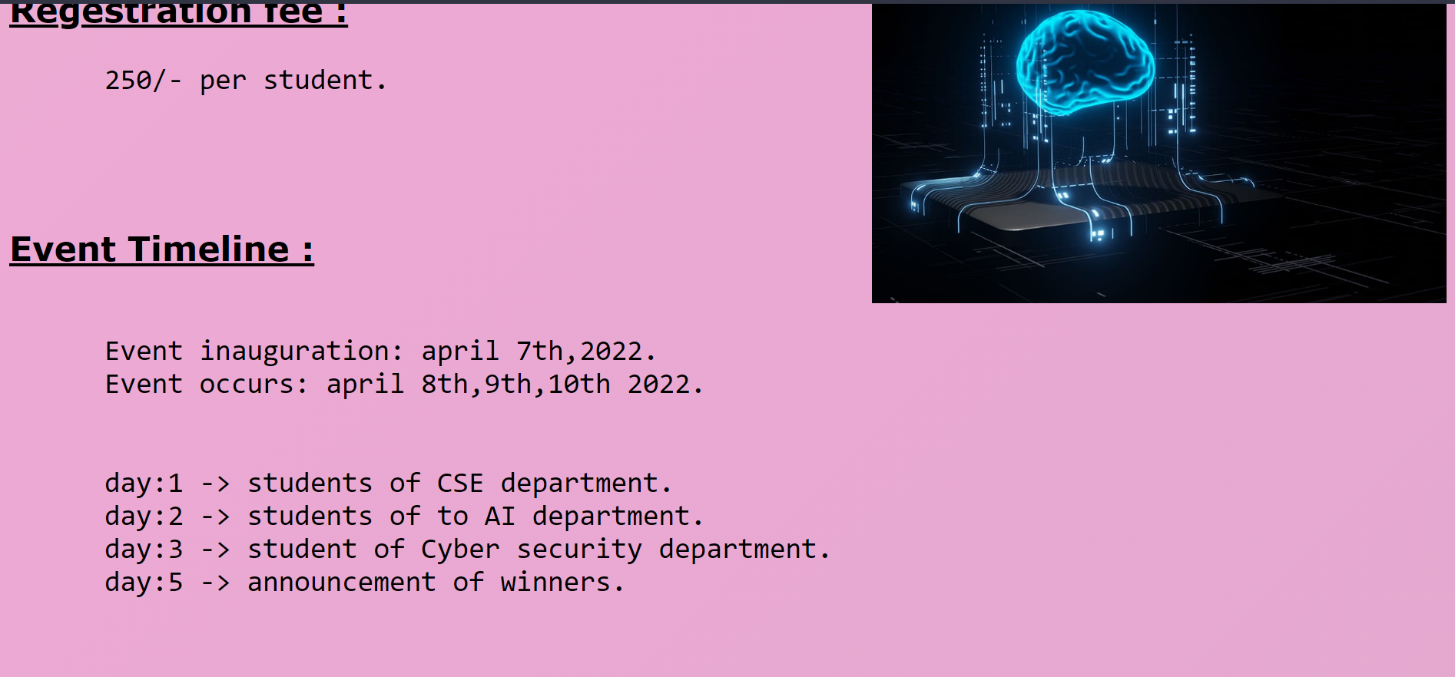

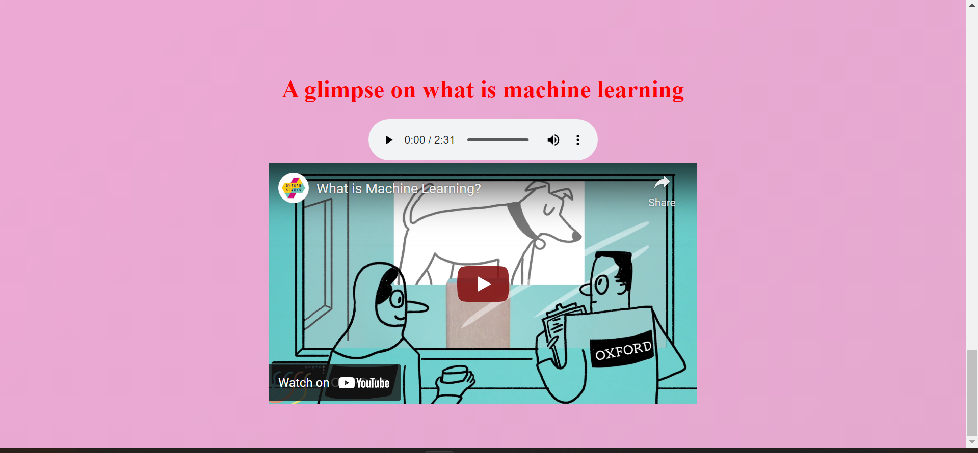

Project PAGE SOURCE:

<!DOCTYPE html>

<html>

</html>

<head>

<title>list of projects on machine learning</title>

</head>

<style>

body{

background-size:cover;

background: linear-gradient(-45deg, #d9a7c7, #eca9d4, #e7e2b4, #fffcdc);

background-size: 400% 400%;

animation: gradient 9s ease infinite;

height: 100vh;

}

@keyframes gradient {

0% {

background-position: 0% 50%;

}

50% {

background-position: 100% 50%;

}

100% {

background-position: 0% 50%;

}

}

h1{

font-family: 'Franklin Gothic Medium', 'Arial Narrow', Arial, sans-serif;

color:red;

font-size: 50px;

}

.pic2{

text-align: end;

}

a:link{

color:orangered;

font-size: 30px;

}

.home{

color: brown;

}

a:visited{

color:blue;

}

</style>

<h3><a target="_blank"; href="index.html">Home</a></h3>

<center><h1> ML real-time projects<h1></h1>

</center>

<center><img src="aml.png" width="70%" height="300px"></center>

<center>

<a target="_blank"; href="https://github.com/ashishpatel26/500-AI-Machine-learning-Deep-learning-Computer-vision-NLP-Projects-with-code">click here to explore with some source codes and more ideas about ML</a>

</center>

<br><br><br>

</body>

SCREENSHOTS :



Videos PAGE SOURCE:

<!doctype html>

<html>

<head>

<title>videos</title>

</head>

<style>

header{

color:blue;

text-align: center;

font-family: 'Trebuchet MS', 'Lucida Sans Unicode', 'Lucida Grande', 'Lucida Sans', Arial, sans-serif;

font-size: 30px;

}

body{

background-color: yellowgreen;

background-size: cover;

}

</style>

<body>

<h2><a href="index.html">Go Back</a></h2>

<header>

<h1>

Videos on how we can explore projects on machine learning

</h1>

</header>

<br> <br> <br> <br>

<div class="scroll" >

<marquee behavior="scroll" direction="left">

<iframe width="560" height="315" src="https://www.youtube.com/embed/6u0bW7NTRV0" title="YouTube video player" frameborder="0" allow="accelerometer; autoplay; clipboard-write; encrypted-media; gyroscope; picture-in-picture" allowfullscreen></iframe>

<iframe width="560" height="315" src="https://www.youtube.com/embed/BOhgGA7Eu5E" title="YouTube video player" frameborder="0" allow="accelerometer; autoplay; clipboard-write; encrypted-media; gyroscope; picture-in-picture" allowfullscreen></iframe>

<iframe width="560" height="315" src="https://www.youtube.com/embed/nKW8Ndu7Mjw" title="YouTube video player" frameborder="0" allow="accelerometer; autoplay; clipboard-write; encrypted-media; gyroscope; picture-in-picture" allowfullscreen></iframe>

<iframe width="560" height="315" src="https://www.youtube.com/embed/y5nChwC0TTs" title="YouTube video player" frameborder="0" allow="accelerometer; autoplay; clipboard-write; encrypted-media; gyroscope; picture-in-picture" allowfullscreen></iframe>

<iframe width="560" height="315" src="https://www.youtube.com/embed/H9yACitf-KM" title="YouTube video player" frameborder="0" allow="accelerometer; autoplay; clipboard-write; encrypted-media; gyroscope; picture-in-picture" allowfullscreen></iframe>

<iframe width="560" height="315" src="https://www.youtube.com/embed/1eBxt9HUfh8" title="YouTube video player" frameborder="0" allow="accelerometer; autoplay; clipboard-write; encrypted-media; gyroscope; picture-in-picture" allowfullscreen></iframe>

<iframe width="560" height="315" src="https://www.youtube.com/embed/6u0bW7NTRV0" title="YouTube video player" frameborder="0" allow="accelerometer; autoplay; clipboard-write; encrypted-media; gyroscope; picture-in-picture" allowfullscreen></iframe>

<iframe width="560" height="315" src="https://www.youtube.com/embed/BOhgGA7Eu5E" title="YouTube video player" frameborder="0" allow="accelerometer; autoplay; clipboard-write; encrypted-media; gyroscope; picture-in-picture" allowfullscreen></iframe>

<iframe width="560" height="315" src="https://www.youtube.com/embed/nKW8Ndu7Mjw" title="YouTube video player" frameborder="0" allow="accelerometer; autoplay; clipboard-write; encrypted-media; gyroscope; picture-in-picture" allowfullscreen></iframe>

<iframe width="560" height="315" src="https://www.youtube.com/embed/y5nChwC0TTs" title="YouTube video player" frameborder="0" allow="accelerometer; autoplay; clipboard-write; encrypted-media; gyroscope; picture-in-picture" allowfullscreen></iframe>

<iframe width="560" height="315" src="https://www.youtube.com/embed/H9yACitf-KM" title="YouTube video player" frameborder="0" allow="accelerometer; autoplay; clipboard-write; encrypted-media; gyroscope; picture-in-picture" allowfullscreen></iframe>

<iframe width="560" height="315" src="https://www.youtube.com/embed/1eBxt9HUfh8" title="YouTube video player" frameborder="0" allow="accelerometer; autoplay; clipboard-write; encrypted-media; gyroscope; picture-in-picture" allowfullscreen></iframe>

</marquee>

<br><br><br>

</body>

</html>

SCREENSHOTS :



CONCLUSION :

1) We have successfully created a webpage for our upcoming science conference

2) By using various html tags which helped to create

this webpage.

3) Also created Separate projects page along with separate videos page.

Task - 4

Forms

AIM : Create a forms page as follows:

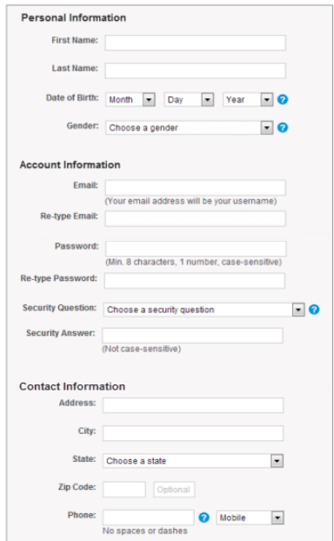

HTML TAGS USED IN THIS WEB PAGE :

* <head> - Heading content of the html file
* <body> - Body content of the html file
* <link> - To link CSS file
* <br> - Breaking line
* <div> - To create a division like a separate container
* <img> - To link an image into the website
* <hx> - heading tag followed by a number noting its size
* <p> - Paragraph tag for text
* <form> - Creating Form
* <input> - To take input from user
* <a> - Attribute link tag
* <select> - Provide a drop down list for the user
* <option> - Display the dropdown options available
* <button> - Create a submit button to the form

HTML CODE FOR MAIN WEB PAGE :

<!DOCTYPE html>

<html lang="en">

<head>

<meta charset="UTF-8">

<meta http-equiv="X-UA-Compatible" content="IE=edge">

<meta name="viewport" content="width=device-width, initial-scale=1.0">

<title>Form</title>

<link rel="icon" type="image" href="https://icons-for-free.com/iconfiles/png/512/clipboard+inventory+list+report+tasks+todo+icon-1320184207175705647.png">

<link rel="stylesheet" href="style.css">

</head>

<body style="padding-left:360px">

<br><br>

<div class="content" >

<form action="data.csv"style="padding-left:50px">

<h4 style="font-size: 120%;font-weight: bold;">Personal Information</h4>

<p style="padding-left: 35px;">First name: <input type="text" placeholder=""></p>

<p style="padding-left: 35px;">Last name: <input type="text" placeholder=""></p>

<p style="padding-left: 35px;">Date of Birth:

<select name="day" id="day">

<option value="0">Month</option>

<option value="1">1</option>

<option value="1">2</option>

<option value="1">3</option>

</select>

<select name="month" id="month">

<option value="0">Day</option>

<option value="1">1</option>

<option value="1">2</option>

<option value="1">3</option>

</select>

<select name="year" id="year">

<option value="0">year</option>

<option value="1">2020</option>

<option value="1">2021</option>

<option value="1">2022</option>

</select>

<img id="question" src="question.png"<p></p>

</p>

<p style="padding-left: 35px;">Gender:

<select name="gender" id="gender">

<option value="0">select your gender</option>

<option value="Female">Female</option>

<option value="male">male</option>

<option value="swaroop">LGBTQ</option>

<option value="ratan">Not to specify</option>

</select> <img id="question" src="question.png"></p>

<h4 style="font-size: 120%;font-weight: bold;">Account Information</h4>

<p style="padding-left: 35px;">Email: <input type="email" placeholder=""> <br><p style="padding-left: 75px;font-size: 70%;">(Your mail adress is your username)</p></p>

<p style="padding-left: 35px;">Re-Type Email: <input type="email" placeholder=""> <br></p>

<p style="padding-left: 35px;">Password: <input type="password" placeholder=""> <br><p style="padding-left: 95px;font-size: 70%;">(Min. 8 characters, 1 number)</p></p>

<p style="padding-left: 35px;">Re-Type Password: <input type="password" placeholder=""> <br></p>

<p style="padding-left: 35px;">Security-Question:

<select name="sq" id="sq">

<option value="0">Choose Your Security Question</option>

<option value="Female">Your pet name</option>

<option value="male">First school name</option>

<option value="swaroop">Your Favourite Teacher Name</option>

<option value="ratan">Your Favourite Quote</option>

</select> <img id="question" src="question.png"></p>

<p style="padding-left: 35px;">Security Answer: <input type="text" placeholder=""> <br><p style="padding-left: 145px;font-size: 70%;">(Not Case-Sensitive)</p></p>

<h4 style="font-size: 120%;font-weight: bold;">Contact Information</h4>

<p style="padding-left: 35px;">Adress: <input type="text" placeholder=""></p>

<p style="padding-left: 35px;">City: <input type="text" placeholder=""></p>

<p style="padding-left: 35px;">State:

<select name="sq" id="sq">

<option value="0">Choose Your State</option>

<option value="1">Arunachal Prades</option>

<option value="2">Andhra pradesh</option>

<option value="3">Assam</option>

<option value="4">Bihar</option>

<option value="5">Chandigarh</option>

<option value="6">Chattisgarh</option>

<option value="7">Delhi</option>

<option value="8">Goa</option>

<option value="1">Gujarat</option>

<option value="2">Haryana</option>

<option value="3">Jammu & kashmir</option>

<option value="4">Karnataka</option>

<option value="5">Kerala</option>

<option value="6">Madya pradesh</option>

<option value="7">Nagaland</option>

<option value="8">Punjab</option>

<option value="3">Tamil Nadu</option>

<option value="4">Telagana</option>

<option value="5">Tripura</option>

<option value="6">Uttarakhand pradesh</option>

<option value="7">Uttar pradesh</option>

<option value="8">West bengal</option>

</select></p>

<p style="padding-left: 35px;">ZipCode: <input type="number" placeholder=""> <br></p>

<p style="padding-left: 35px;">Phone: <input type="number" placeholder="">

<img id="question" src="question.png">

<select name="sq" id="sq">

<option value="0">Mobile</option>

<option value="1">Landline</option>

<option value="2">Telephone</option>

</select>

<br>

<p style="padding-left: 95px;font-size: 70%;">(Not Case-Sensitive)</p>

</p>

<button>Submit</button>

</form>

<br><br>

</div>

<br><br>

</body>

</html>

CSS CODE FOR Main Site :

body{

background-image: url("bg.jpeg");

}

.content {

padding-left: 2px;

border: none;

overflow: scroll;

height:520px;

width:70%;

background-color: rgba(255, 255,255, 0.7);

border-radius: 10px;

}

/* Scrollbar styles */

::-webkit-scrollbar {

width: 12px;

height: 12px;

}

::-webkit-scrollbar-thumb {

background: white;

border-radius: 10px;

}

.content .q .a{

background-image: url(question.png);

}

#question{

width: 2%;

}

SCREENSHOTS :

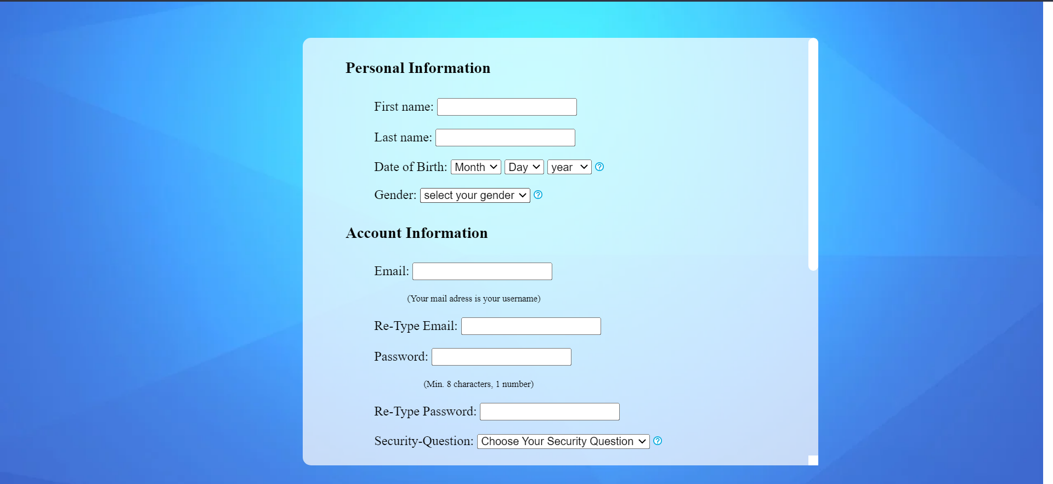

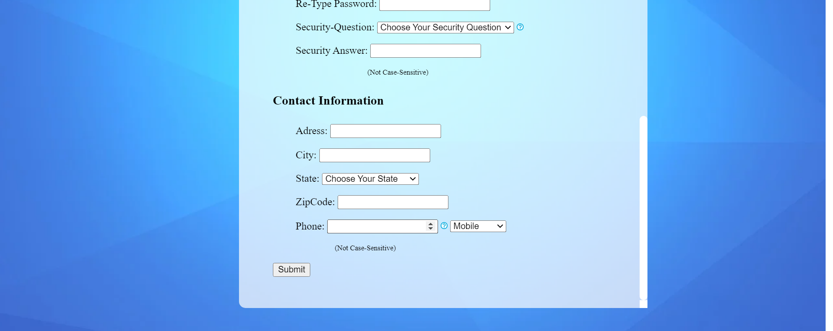

CONCLUSION :

1) We have successfully created a webpage for form submissions.

2) By using various html tags we have created this webpage.

Task - 5

CSS

AIM : Create simple single web page demonstrating CSS borders, backgrounds, any one TEXT effects and Using Layout

HTML TAGS USED IN THIS WEB PAGE :

* <head> - Heading content of the html file
* <body> - Body content of the html file
* <link> - To link CSS file
* <br> - Breaking line
* <div> - To create a division like a separate container
* <img> - To link an image into the website
* <p> - Paragraph tag for text
* <centre> - Creating Form
* <textarea> - To take input from user

HTML CODE FOR MAIN WEB PAGE :

<!DOCTYPE html>

<html lang="en">

<head>

<meta charset="UTF-8">

<meta http-equiv="X-UA-Compatible" content="IE=edge">

<meta name="viewport" content="width=device-width, initial-scale=1.0">

<title>CSS Styles</title>

<link rel="stylesheet" href="styles.css">

</head>

<body>

<div class="one">

<center >

<p>First Div </p></center>

<p>whose heading is contained in double red border </p>

<p>And whole div having dashed border of green color</p>

</div>

<div class="two">

<center >

<p>Second Div </p>

<p>whose Background is filled with an image </p>

<p>And whole div having double border of yellow color</p></center>

</div>

<div class="three">

<center >

<p>Third Div </p></center>

<p>whose background color is bisque color </p>

</div>

<div class="four">

<center >

<p>Textbox Div </p></center>

<textarea cols="41" rows="10">

This is text box wrapped in a div of grid display

Lorem ipsum dolor sit amet, consectetur adipisicing elit. Fugit perspiciatis quae placeat nulla, magnam ducimus ab rem quia est dolore rerum possimus distinctio cumque quos quis eveniet nesciunt sed illum officia beatae! Perspiciatis voluptate tenetur voluptatem est blanditiis nobis quis laborum, architecto nemo hic alias doloribus, molestias cupiditate, accusamus sequi!

</textarea>

</div>

<div class="five">

<img src="download.png" alt="" width="100%">

</div>

<div class="six" style="display: grid; grid-template-columns: auto auto; grid-template-rows: auto auto; color:aliceblue">

<div style="background-color: rgba(237, 10, 10);">

<p>grid 1</p>

</div>

<div style="background-color: rgba(94, 6, 6);">

<p>grid 2</p>

</div>

<div style="background-color: rgb(255, 4, 4);">

<p>grid 3</p>

</div>

<div style="background-color: rgb(165, 6, 6);">

<p>grid 4</p>

</div>

</div>

<div class="seven">

<p>End of Boarders content havig mixed borders</p>

</div>

</body>

</html>

CSS CODE FOR Main Site :

body{

background-color: black;

border: dotted 4px orange;

display: grid;

grid-template-columns: auto auto auto;

grid-template-rows: auto auto auto;

column-gap: 20px;

row-gap: 20px;

}

.one{

color: white;

background-color: rgba(13, 1, 1, 0.062);

border: dashed 4px green;

}

.one center{

background-color: whitesmoke;

color: black;

border: double 5px red;

}

.two{

color: black;

background: url('download.jpg');

border: double 4px yellow;

}

.three{

border: ridge 2px olive;

background-color: bisque;

}

.four{

border: solid 2px white;

}

.four center{

background-color: whitesmoke;

color: black;

border: inset 5px orangered;

}

.five{

border: solid 2px orange;

}

.six{

border: outset 2px goldenrod;

}

.seven{

border-style: dashed double dotted inset;

border-color: aqua;

color: azure;

}

SCREENSHOTS :

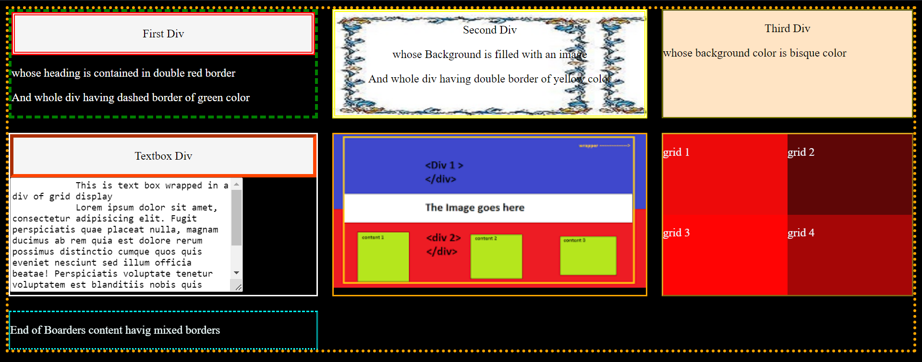

CONCLUSION :

1) We have successfully created a webpage which can explain css layouts.

2) By using various css styles we have created this webpage.